Crack The Covid – 19 Crisis

By NASSCOM Future Skills and IBM

**TEAM NAME: Creators:** Engineers make the world

Title of the Proposed Project: **Smart Irrigation**

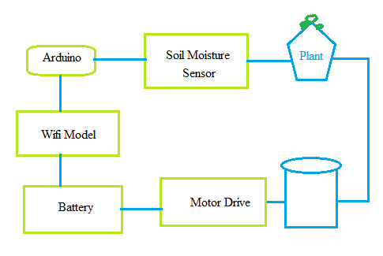

**Source Code**

int sensor_pin=A0;

pin A0

int ouput_value;

void setup()

{

//put your setup code here,to run once:

pinmode(4,OUTPUT);

serial.begin(9600);

serial.println("reading from the sensor")'

delay(2000);

}

//put your main code here,to run repeatedly:

void loop()

{

output_value=analogread(sensor_pin);

output_value=map(output_value);

serial.print("moisture:");

serial.print(output_value);

serial.println("%");

if(output_value<0)

{

digitalwrite(4,high);

}

else

{

digitalwrite(4,low);

}

delay(1000);

}